UML Diagrams
(Online Food Ordering Website)

- DFD Diagram – Level 0.
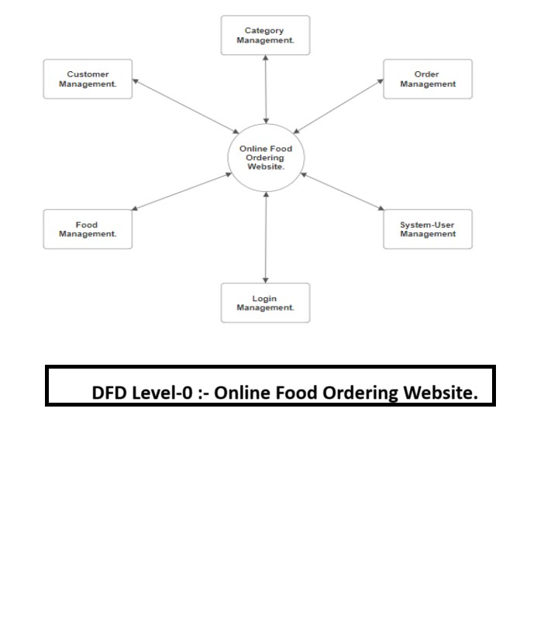
- DFD Diagram – Level 1. 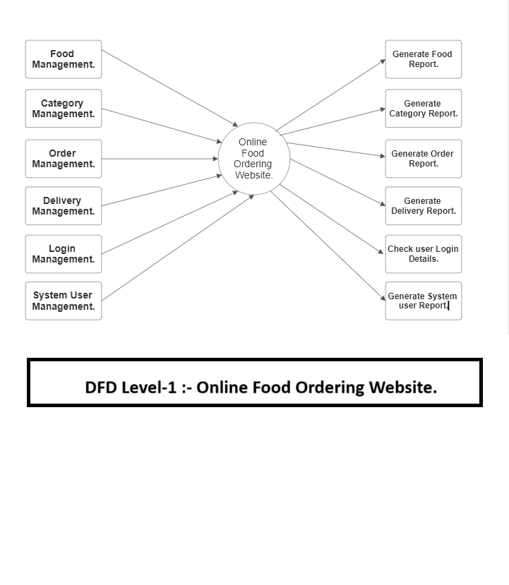
- Class Diagram.

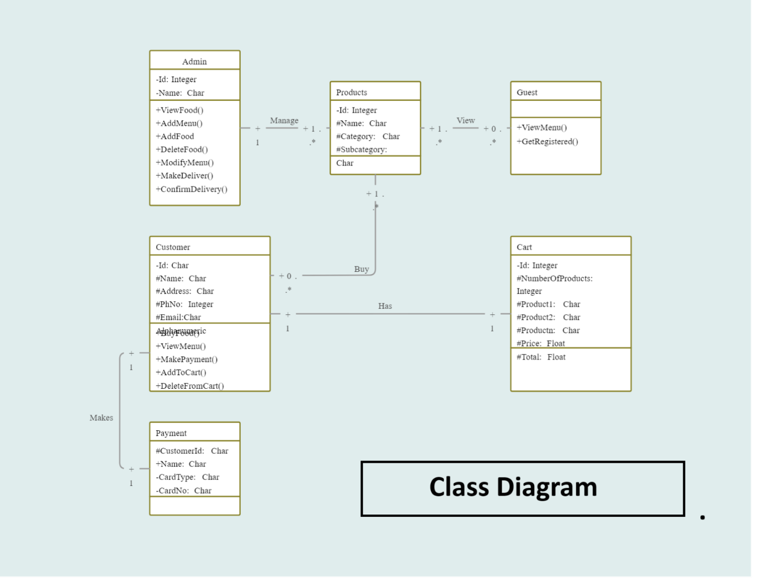

- Sequence Diagram.

